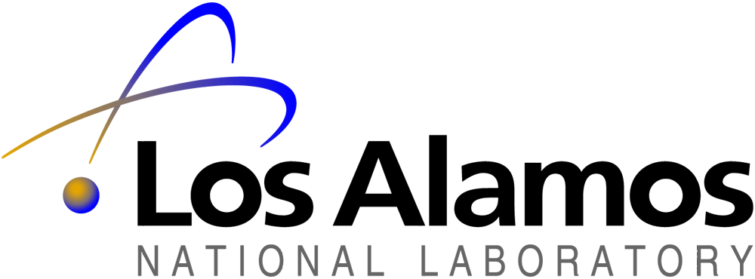

National Flow Cytometry Resource, B-2
Bioscience Division, Mail Stop M888
Los Alamos, New Mexico 87545
505/667-3912/Fax 505/665-4096

February 16, 2007
Enclosed is information on the Annual Course in Flow Cytometry that will be held June 9-15, 2007. The course is being co-sponsored by the National Flow Cytometry Resource and Verity Software House. The course will be held at the Los Alamos National Laboratory, National Flow Cytometry Resource, in Los Alamos. This is an advanced course and a statement of flow cytometry experience is required.
The course registration fee is $1700.00 (U.S.) that includes course materials, lunches during the week, two evening sessions with refreshments and a banquet on Thursday evening. Additional expenses for lodging and other meals are not included in the registration fee. Places in the course are reserved on a first come, first served basis, determined by our receipt of the registration fee. Due to the popularity of the course, we would recommend that interested participants send their registration fees as soon as possible. Checks should be made out to LANL: 2007 Annual Workshop in Flow Cytometry (U9YC) and mailed with the attached registration form to:
2007 Annual Workshop in Flow Cytometry (U9YC)
Attn: Ruby Archuleta
MS M888, B-5
Los Alamos National Laboratory
Los Alamos, NM 87545
It is important that the registration check and the registration form be filled out and mailed as requested.
Registration / reception will be held on Saturday, June 9^{th,} at 7:00p.m. The first lecture session will be on Sunday afternoon at 1:00p.m.. A detailed lecture and laboratory schedule will be provided at a later date. A block of rooms has been reserved at the Best Western Hilltop House Hotel for course participants and faculty. It is NOT necessary for you to make lodging reservations at this time. Additional lodging and transportation information will be sent to you upon acceptance into the course. Rental cars are available at the Albuquerque International Airport. It is a 1 hour 45 minute drive from Albuquerque to Los Alamos. The course will end Friday at approximately 12:30p.m. to allow east coast participants time to make flight connections home.
If you have any questions concerning the course or the registration process, please feel free to call Ruby at 505/667-3912. We are looking forward to seeing you in June.

Sincerely,
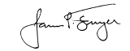
James P. Freyer, Ph.D.
Director NFCR

